Project Design Phase
Solution Architecture

Date | 20 February 2026
Team ID | LTVIP2026TMIDS90751
Project Name | Exploratory Analysis of Rainfall Data in India for Agriculture
Maximum Marks | 4 Marks

Solution Architecture:s
Solution architecture is a complex process – with many sub-processes – that bridges the gap between business problems and technology solutions. Its goals are to:
- Find the best tech solution to solve existing business problems.
- Describe the structure, characteristics, behaviour, and other aspects of the software to project stakeholders.
- Define features, development phases, and solution requirements.
- Provide specifications according to which the solution is defined, managed, and delivered.

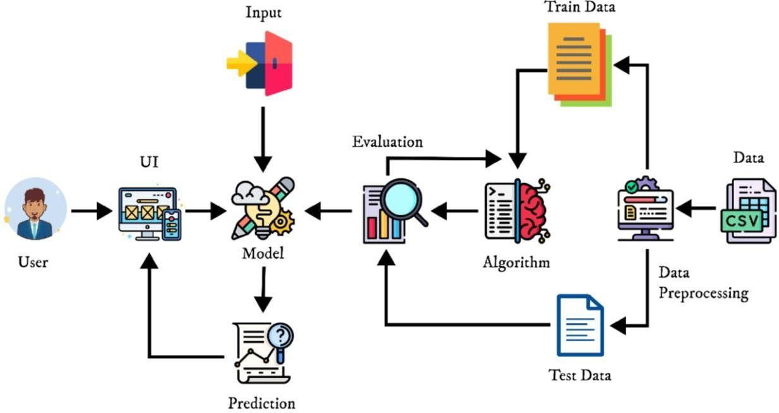
Example - Solution Architecture Diagram:

SOLUTION ARCHITECTURE
(Minimum Viable Architecture/ Product)

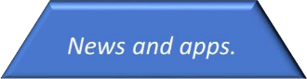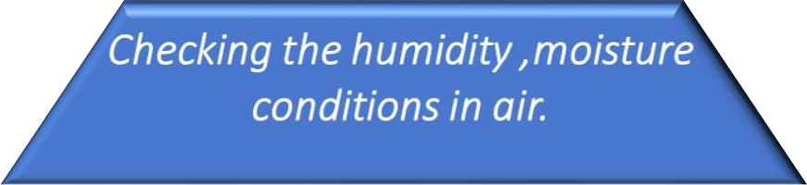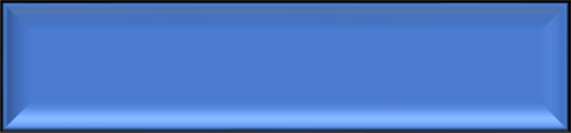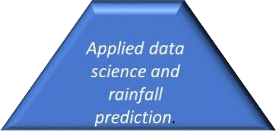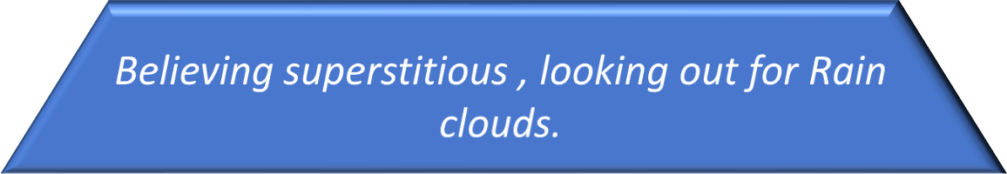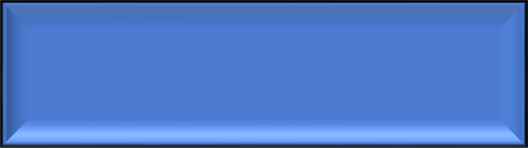

Checking

the

moisture conditions

in

air

seems to be

reliable

and

well worked
.

Reliablity

In

current

situation

people

uses

weather

report

channels

to predict

rainfall.

Usability

Design

THIS

IS THE

FUTURE

!

Functionality

In

olden

days

people

used

to

look

at the

skies

and

predict

the

rainfall
.

